Nandini Ramakrishnan

Ramakrishnan_Nandini_Proj3

1. **Overview of project idea**. This should be the high level vision, not details of the simulator for this project. Imagine this is your pitch for a new product you will be creating and selling.

The project idea focuses on improving the field of telemedicine by enhancing remote doctor appointments through audio-based interfaces. Telemedicine, the practice of providing healthcare remotely, has become essential to reaching wider audiences and improving the accessibility of medicine, especially during the Covid-19 pandemic. The project aims to address challenges in telemedicine (specifically general health checkups), such as patient privacy, accurate diagnoses, and doctor-patient relationships, by utilizing audio-based interfaces. When using this product, doctors will get sent real-time patient data, better simulating an in-person appointment remotely. Doctors will get notified of any breathing patterns, heart rate, tremors, etc. that the patient is exhibiting in real time, and will be better able to connect with their patients on a remote platform.

1. **Final versions of your user persona and scenarios**. You will have refined and improved your scenarios so provide those to help inform your software design decisions.

* Doctor Persona
  + Background: Dr. [last name] is an experienced general practitioner with over 10 years of practice. They work at a clinic, which is just starting to offer telemedicine services to reach a wider patient base.
  + Problems and Frustrations: The doctor persona encounters frustrations (such as the inability to conduct comprehensive patient examinations due to limitations from the remote platform). They also struggle with the challenge of maximizing patient satisfaction and continuously monitoring basic patient conditions because of insufficient connectivity in the remote setting. Additionally, the doctor persona faces challenges in accurately assessing a patient’s condition during remote general health checkups. They struggle with the difficulty of ensuring patients feel they are receiving optimal care in a remote setting.
  + Goals: The doctor’s immediate goal is to enhance support for all patients and expand their reach through a remote platform. Their main motivation for utilizing this tool is to provide excellent service to patients and create a virtual appointment experience that closely mimics in-person consultations, incorporating audio cues from the patient. They aim to maximize patient satisfaction, ensure continuous audio monitoring throughout the session, and establish a personalized atmosphere.
  + Needs: To achieve their goals, the doctor needs to be situated in their office or hospital, with reliable Wi-Fi or network connectivity, and possess a high level of expertise in their field. In order for the doctor to be able to properly make use of the product, the product must have the capability to identify various patient factors such as breathing patterns, essential tremors, heart rate, blood pressure, voice signals, indicators of hesitance/eagerness in responses, and other relevant details. It should continuously monitor these parameters without the need for manual activation or deactivation. If the system detects any abnormalities in these aspects, it should promptly alert the doctor, ensuring the same level of notification for both doctor and patient personas.
* Patient Persona (one example)
  + Background: Patient [patient name] is a tech-savvy individual in their late 20s, who, due to their busy schedule, would like to attend remotely-conducted general checkups rather than having to take time to drive to and sit in the waiting room of a hospital or clinic. They are open to trying out the remote system (as it saves time and is more convenient), but would also like to be satisfied with the level of care they receive from the doctor remotely.
  + Problems and Frustrations: Mx. [patient name] has encountered challenges with remote appointments, including inadequate care from remote systems, suboptimal treatment, limited interaction with their doctors, and dissatisfaction with the doctor-patient relationship’s quality. Furthermore, this persona has experienced frustrations such as not experiencing the same level of care and personal connection as in in-person appointments, inadequate treatment due to the absence of face-to-face consultations, and a sense of disconnection with their doctors, feeling that the physician does not invest enough effort in providing accurate diagnoses and proper care.
  + Goals: Mx. [patient name] wants a seamless remote healthcare experience. They seek accurate diagnoses, meaningful interactions with doctors, and the assurance that their privacy is respected. This persona also desires the ability to receive appropriate remote care, enhance doctor-patient interaction, and obtain accurate diagnoses for their concerns during a general health checkup.
  + Needs: Patient [patient name] needs to end their appointments with satisfaction with the level of communication and care, as well as confidence in the remote monitoring feedback. From the patient persona’s perspective, this product needs to possess the capability to properly identify patient breathing patterns, essential tremors, heart rate, blood pressure, voice signals, indicators of hesitance/eagerness in responses, and/or other relevant patient details. It should continuously monitor these parameters without requiring manual initiation or termination.
* Scenario 1: Monitoring Breathing Patterns
  + The initial scenario the system will address involves continuous monitoring of the patient's breathing patterns. This tool is designed for doctors to remotely oversee their patients. The conveyed data may include breathing sounds, breath rate, and any irregular breathing patterns or pauses. Throughout the appointment, the doctor can utilize this information to assess the patient’s condition. The doctor persona will ideally use the system to diagnose (unseen) respiratory conditions, track patient progress (especially if the patient is on medications or a recovery plan), and identify potential sleep disorders. If the data indicates normalcy, the doctor proceeds with the appointment, confirming the patient’s good health. However, if abnormal patterns emerge, the doctor can take appropriate actions based on the situation. For instance, the doctor can guide the patient through exercises to improve their breathing, educate them about signs to watch for, or, in more severe cases, schedule an in-person appointment for medication and treatment. The doctor can communicate with the system through verbal commands (in a voice-controlled system) or text-based inputs, indicating that they have observed the signs and will respond accordingly.
* Scenario 2: Assessing Essential Tremors and Stress Signs
  + The system’s second scenario involves ensuring that patients do not exhibit signs of essential tremors or excessive stress. As stated before, doctors should utilize this system remotely, receiving audio data such as tremor sounds, voice fluctuations, and speech patterns. The doctor interprets this data to diagnose stress disorders and prescribe appropriate medications or treatments as needed. If the data appears normal, there is no alert to the doctor. However, if the system detects concerning signs, the doctor is promptly notified and can respond accordingly. For example, if a patient’s hand starts shaking violently (it will be detectable through audio as a repeating noise), the system alerts the doctor, who can then take steps to calm the patient, identify the stressor, and make a diagnosis based on the situation. The doctor persona will then communicate back with the system using numeric inputs or buttons, indicating that the issue has been addressed.
* Scenario 3: Enhancing Patient Satisfaction
  + Lastly, the system can also assist in a third scenario, which involves assessing the patient’s satisfaction with the appointment. Since doctors use this system remotely, receiving data on response time, patients’ vocal tone, and other voice cues can also indicate their happiness and contentment. The doctor interprets this data through the system’s outputs, gauging the patient’s mental state. As the data fluctuates, the doctor can adapt their approach to improve the patient’s experience. If specific behaviors positively affect the patient’s satisfaction, the doctor continues employing those strategies, and if the patient appears dissatisfied, the doctor can enhance interaction, proactively engaging the patient to address their concerns. Additionally, the doctor communicates with the system through buttons and numeric input, marking specific alerts as resolved. This informs the system that the doctor is actively addressing these issues.

1. **Sensor Data Description.** Define the data stream that will be consumed by the simulator (e.g. mock up data that would be coming from sensors and information sources like GPS, body poses, accelerometers, activity recognition, Google Maps data, etc). Provide the data types and parameters via JSON examples. Describe how UI elements will also generate data.

The data stream that will be consumed by the simulator will be a continuous stream, monitoring various audio cues from the patient throughout the appointment. It can be classified into the following categories: breathing patterns, tremors and stress, patient interaction data, speech patterns, and doctor instructions. The JSON examples are as follows:

* Breathing Patterns
  + {
  + "sensor_type": "breathing_patterns",
  + "patient_id": "12345",
  + "breath_rate": 18,
  + "irregularities": false,
  + "breath_sounds": {
  + "inhale": "normal",
  + "exhale": "normal"
  + }
  + }
* Tremors and Stress
  + {
  + "sensor_type": "tremor_and_stress",
  + "patient_id": "12345",
  + "hand_tremor_intensity": 0.2,
  + "voice_tremor_intensity": 0.1,
  + "speech_pattern": "calm"
  + }
* Patient Interaction Data
  + {
  + "sensor_type": "patient_interaction",
  + "patient_id": "12345",
  + "response_time": 300,
  + "emotional_state": "happy",
  + "satisfaction": "satisfied"
  + }
* Speech Patterns
  + {
  + "speech_pattern": "calm",
  + "voice_tremors": 0.1,
  + "ambient_noise_level": 30
  + }
* Doctor Instructions
  + {
  + "interaction_type": "button_click",
  + "element_id": "medication_reminder_button",
  + "timestamp": "2023-10-26T14:30:00Z"
  + }
  + {
  + "interaction_type": "doctor_instruction",
  + "instruction_text": "Please demonstrate how you take your medication."
  + }

UI will also generate data in the form of button clicks, form submissions, slider adjustments, and text input. When an alert is posted to the doctor, they can press a button to let the system know that the alert is being taken care of. When a patient submits a form with health-related information, the form data along with the timestamp is generated. The form results can be shared with the doctor to help improve patient satisfaction. The doctor/researcher can also adjust sliders for volume and audio filters for clarity (so they can hear certain parts of their patient’s audio better). The patient and doctor can also communicate with each other using text input, and the system can also use text-to-speech modifications to make verbal communication clearer.

1. **Describe the user experience of your simulator.** What are the UI elements that the researcher will interact with, what will the user hear, and how will the sensor data stream and the UI modify that? Are there visual elements to display as well?

The UI elements of the product that the researcher (the doctor) will interact with are on-screen buttons, live mic input, on-screen information from the product to the doctor/researcher, sonification of data, sliders for sonification volume, and on/off switches for various filters and sound modification UGens.

First, the on-screen buttons will light up on screen when there is something urgent that the doctor needs to address, such as patient breathing issues or stress patterns. These buttons will light up when there is something the doctor/researcher needs to immediately address, thus alerting the doctor. When the doctor presses the button, it will let the system know that the issue has been addressed or taken care of.

The live mic input coming in from the doctor will primarily consist of yes or no answers. It allows the doctor (if they are busy with their hands or doing other things at the same time) to use their voice to answer questions or let the product know that certain issues are being attended to.

Next, the product will display on-screen information, such as relevant patient information, medical history, and real-time data visualizations. The doctor can view this information to understand the patient’s background and current health status. As an example, the patient’s name, age, known medical conditions, and live vital signs (heart rate, blood pressure) can be displayed for the doctor to read.

The product will also perform the sonification of data that comes in from the patient. The sonification data converts patient data (breathing patterns, heart rate) into auditory cues, enabling the doctor to hear variations. The auditory feedback allows the doctor to assess the patient’s condition not just visually, but also through sound. Using sliders to adjust the volume of sonified data will ensure clarity without overwhelming the user. The doctor/researcher can slide these controls to find the optimal volume for auditory cues. For example, if the doctor wants to focus on breathing patterns, they can increase the volume of the breathing sonification.

Finally, on/off switches for filters and sound modification UGens enable or disable specific filters and modifications in the auditory representation of patient data. The doctor can toggle these switches based on preference and the specific data they want to focus on. For instance, a filter can enhance specific frequencies in the patient’s voice for clearer communication.

1. **Software architecture.** provide an initial software diagram showing the functional software elements you will be building, how information will be passed between them, and the data structure that will be used to contain that information.

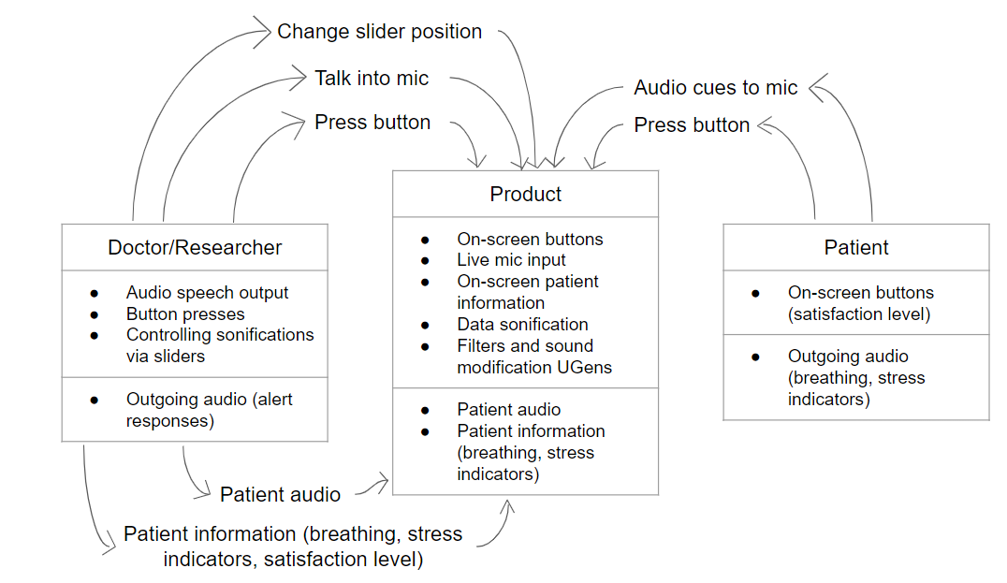

1. **Provide a detailed timeline** describing each milestone (***which should be much more detailed than simply listing the project deliverable due dates***). Prove to the instructors that you will be able to complete a strong project within the time and logistical constraints.

| Deadline | Task |
| --- | --- |
| November 8 | Research Questions- background research, have fully-completed, detailed, and specific research questions for the project |
| November 10 | Participants and Recruiting- choose the final sample population for the patients and write out a detailed description |
| November 12 (Sunday night) | Measures- finalize the exact measurements this product will take, as well as how they will be reported to the doctor |
| November 12 (also Sunday night) | Protocol- write out the specific method to test and track the effectiveness of the product (includes research training, consent, and specific scenarios) |
| November 12 (also Sunday night) | Analysis- describe the data analysis, what kinds of data will be gained, how they will be interpreted |
| November 17 | Attend feedback/demo session, make corrections, and turn in final project deliverable 5 |
| November 17 | Have the full base of the product completed (have everything I wanted to be implemented in the product completed) |
| November 19 (Sunday night) | Finish deliverable 4 (the implementation), by making sure all the project requirements are met |
| November 21 | Finish the user manual and turn in project deliverable 4 |
| November 24 | Have an outline for project deliverable 5 (the sections of the final paper plus what information will go into each section) |
| November 26 (Sunday night) | Abstract and Introduction- write out both, make sure to include a short summary and key findings, as well as background research about the problem, questions, and what the product aims to do |
| November 30 | Methods- describe in detail the process of collecting data, as well as any possible shortcomings of the data collection and accuracy |
| December 2 (Saturday night) | Results- run the study on at least 3 participants, display the results (in raw number form, using tables, statistics, etc.) |
| December 3 (Sunday night) | Discussion and Conclusion- summarize results in word form, discuss the research questions and whether or not they have been properly answered, describe next steps, talk about limitations and implications of project results |
| December 5 | Final project check and turn in- make sure the final paper meets all the requirements, turn in project deliverable 6 |